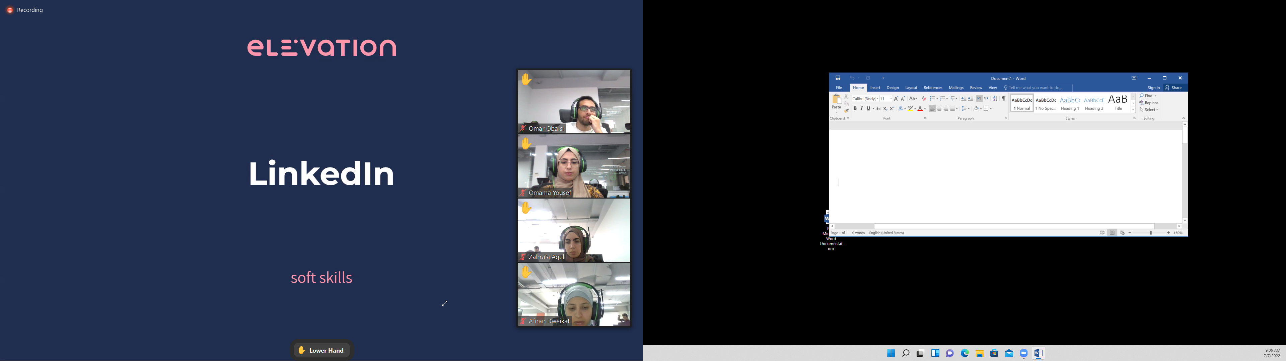

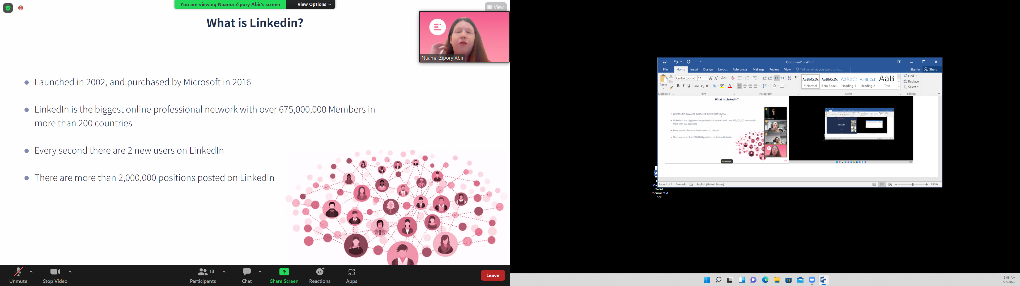

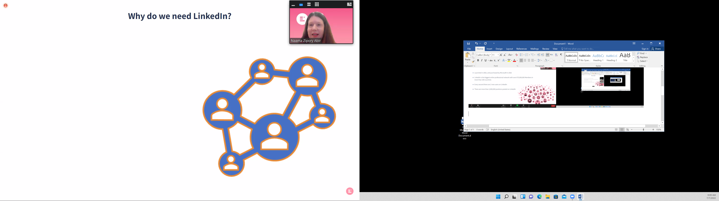

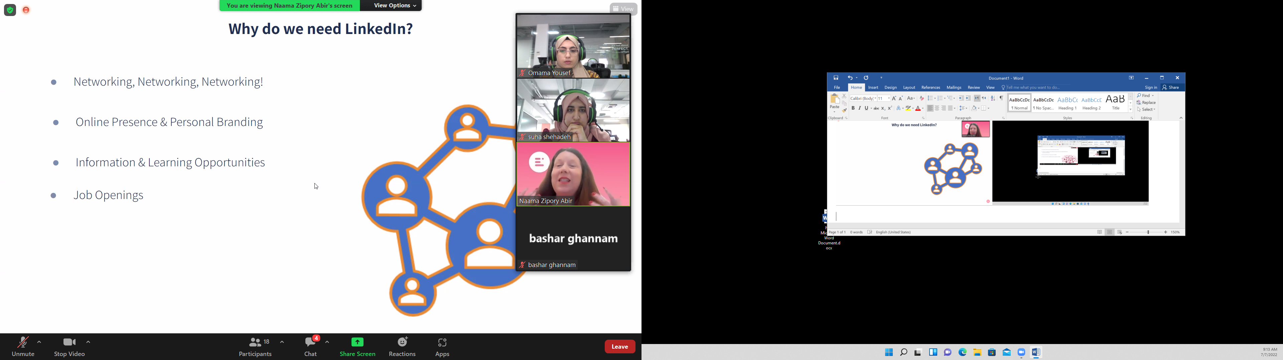

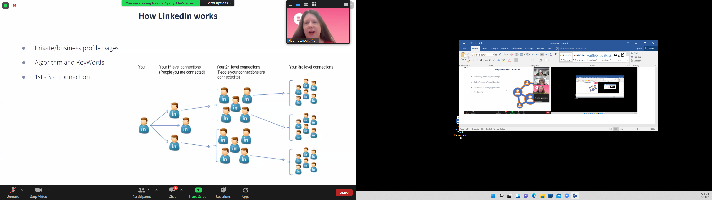

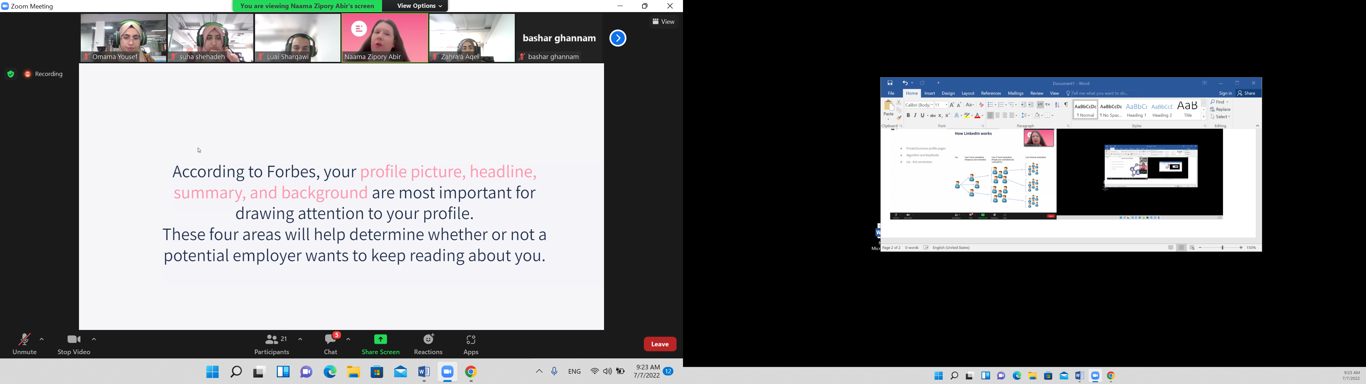

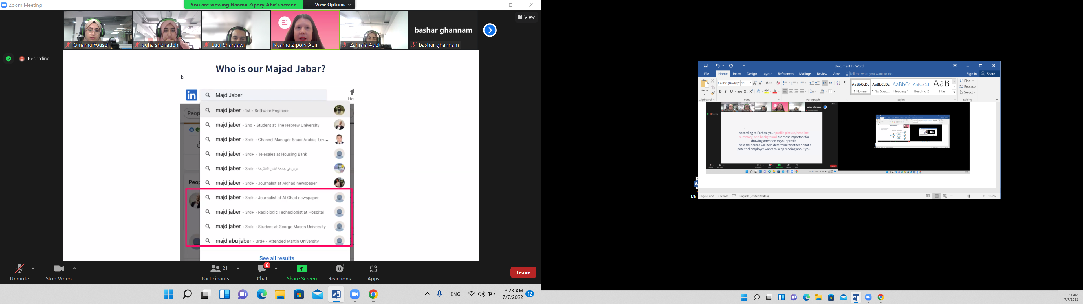

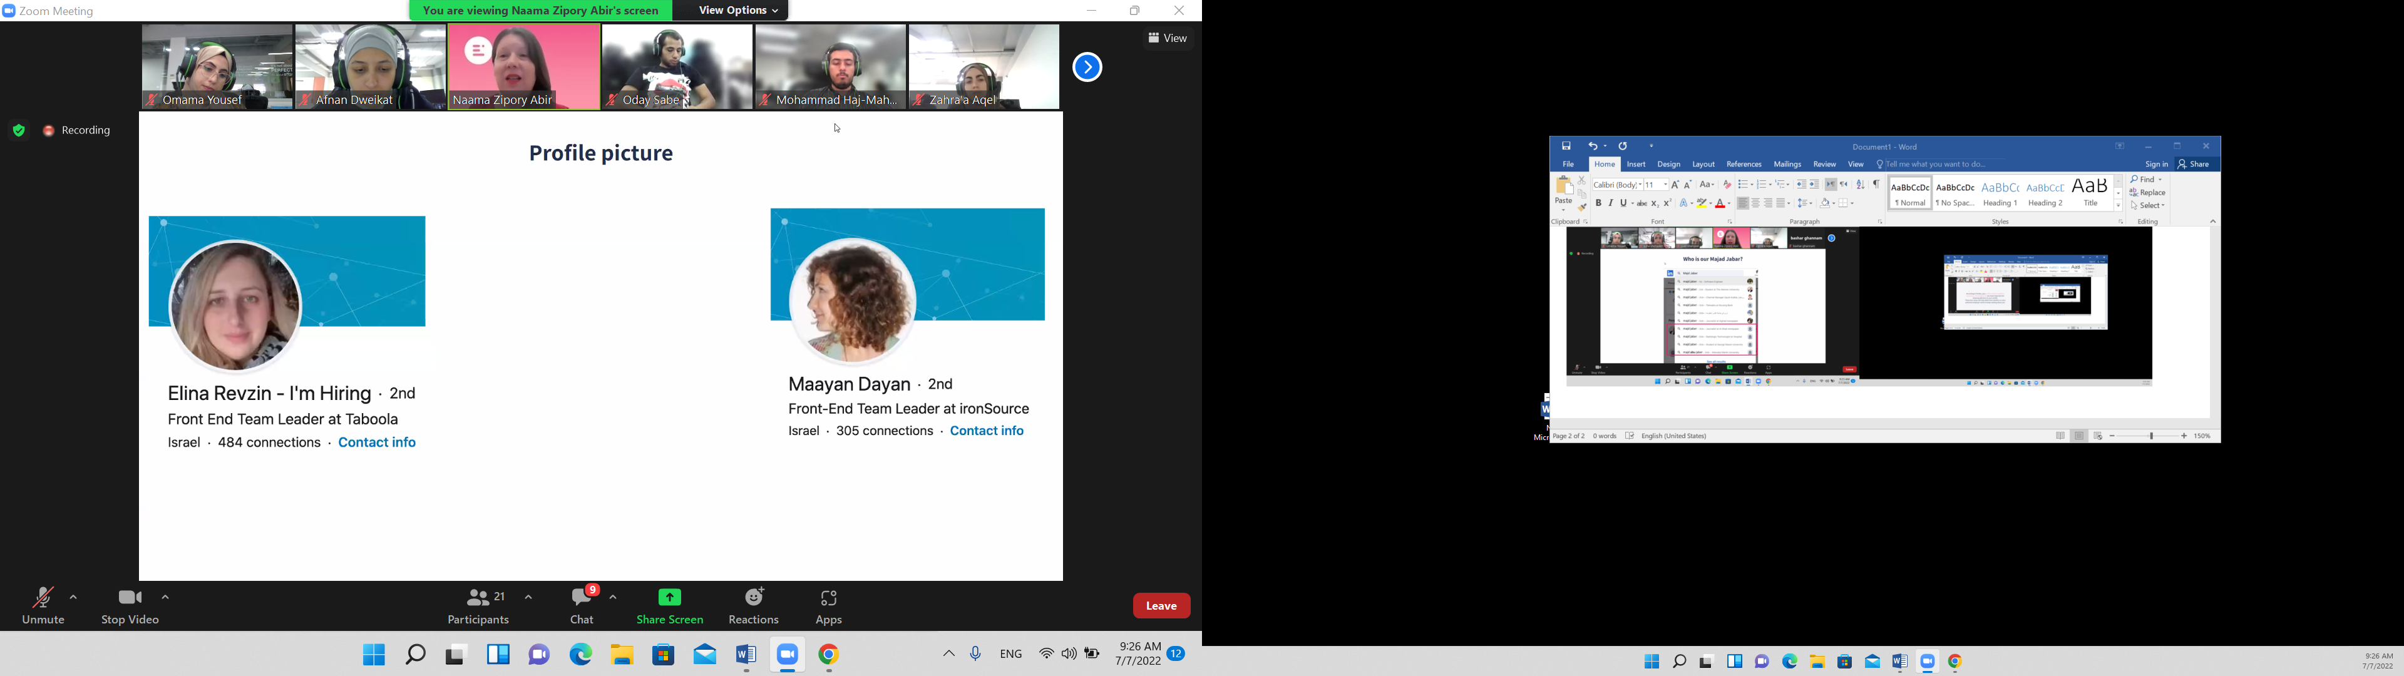

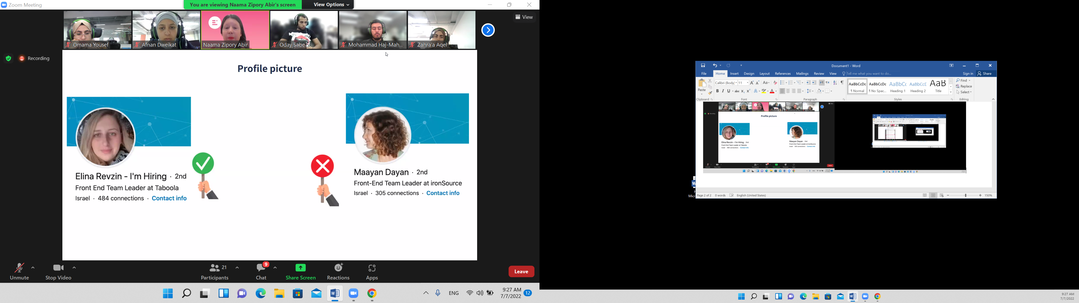

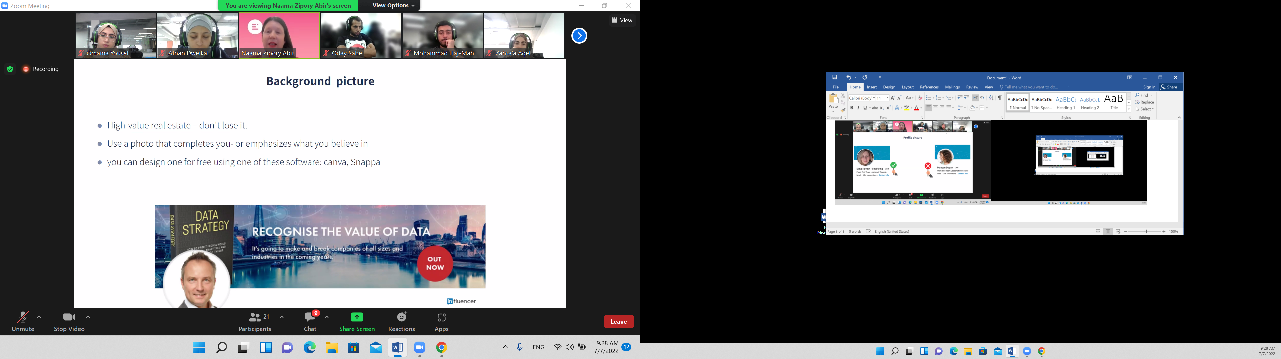

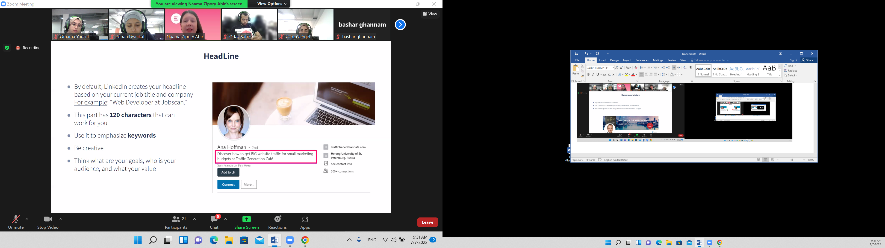

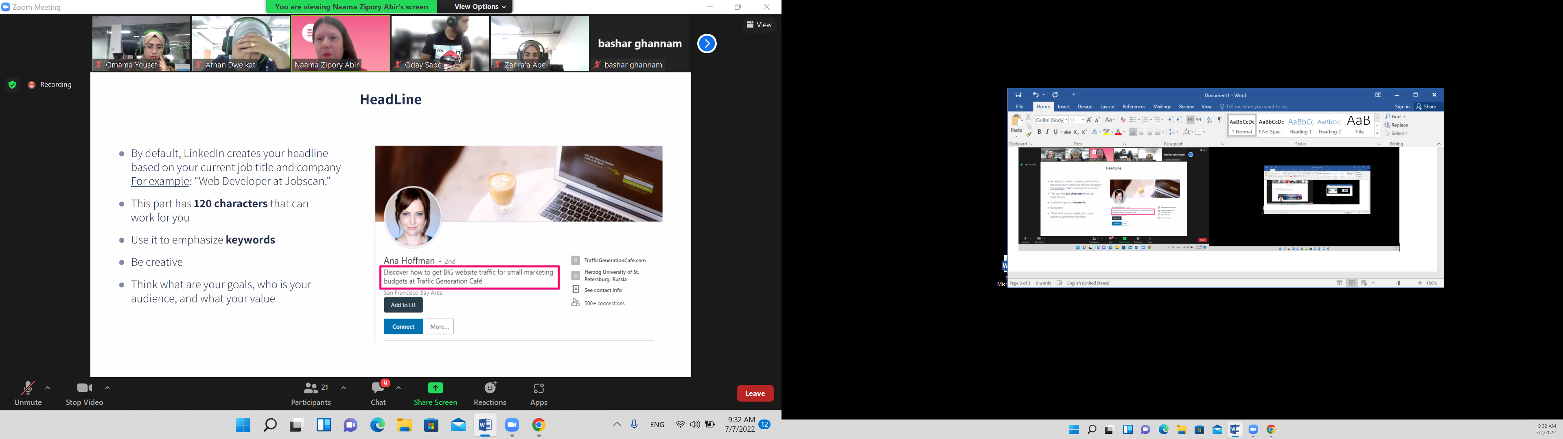

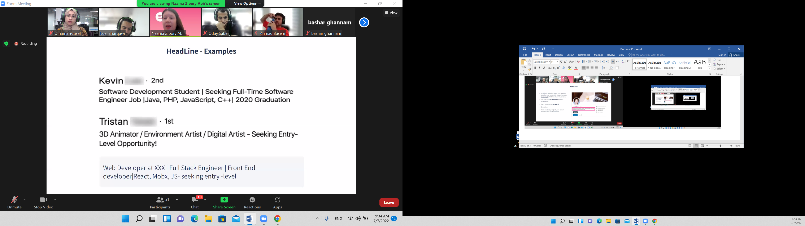

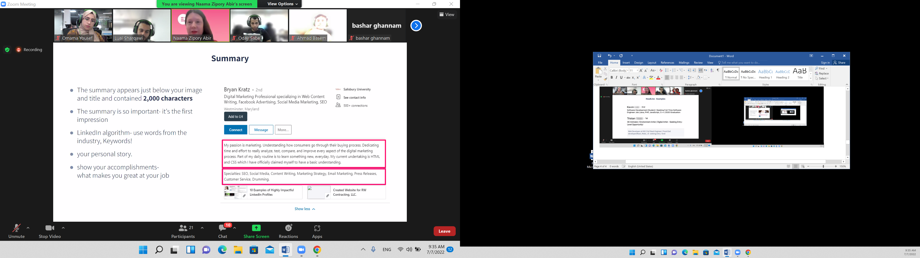

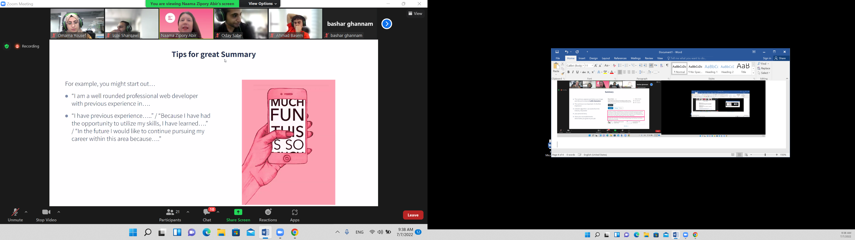

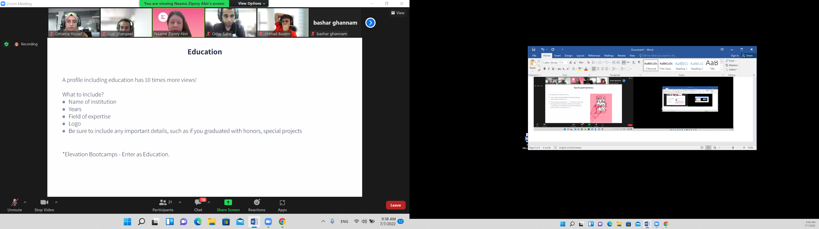

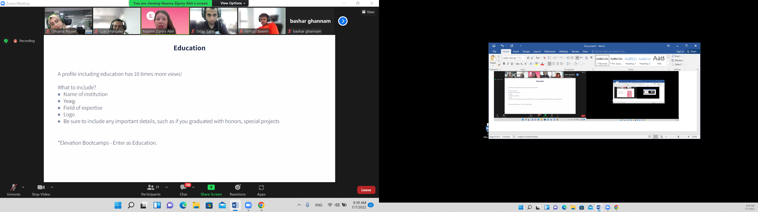

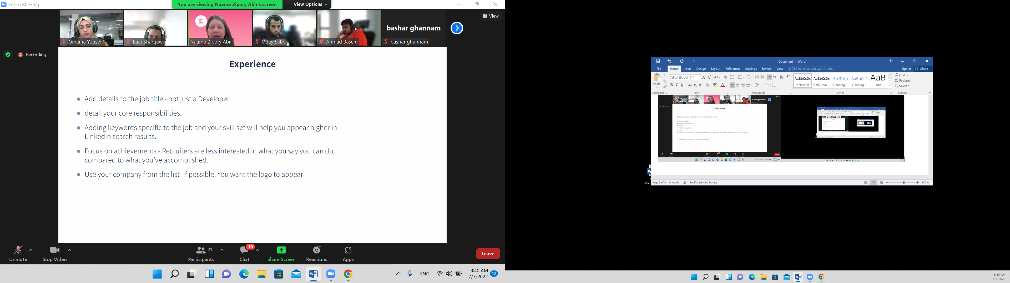

Full stack web developer

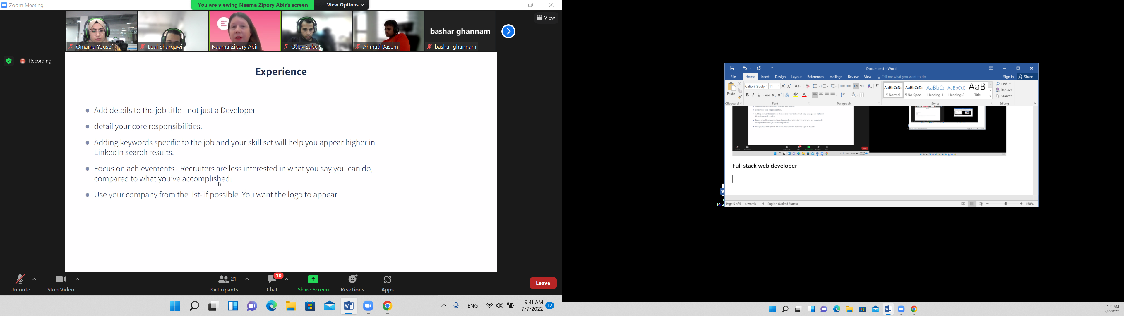

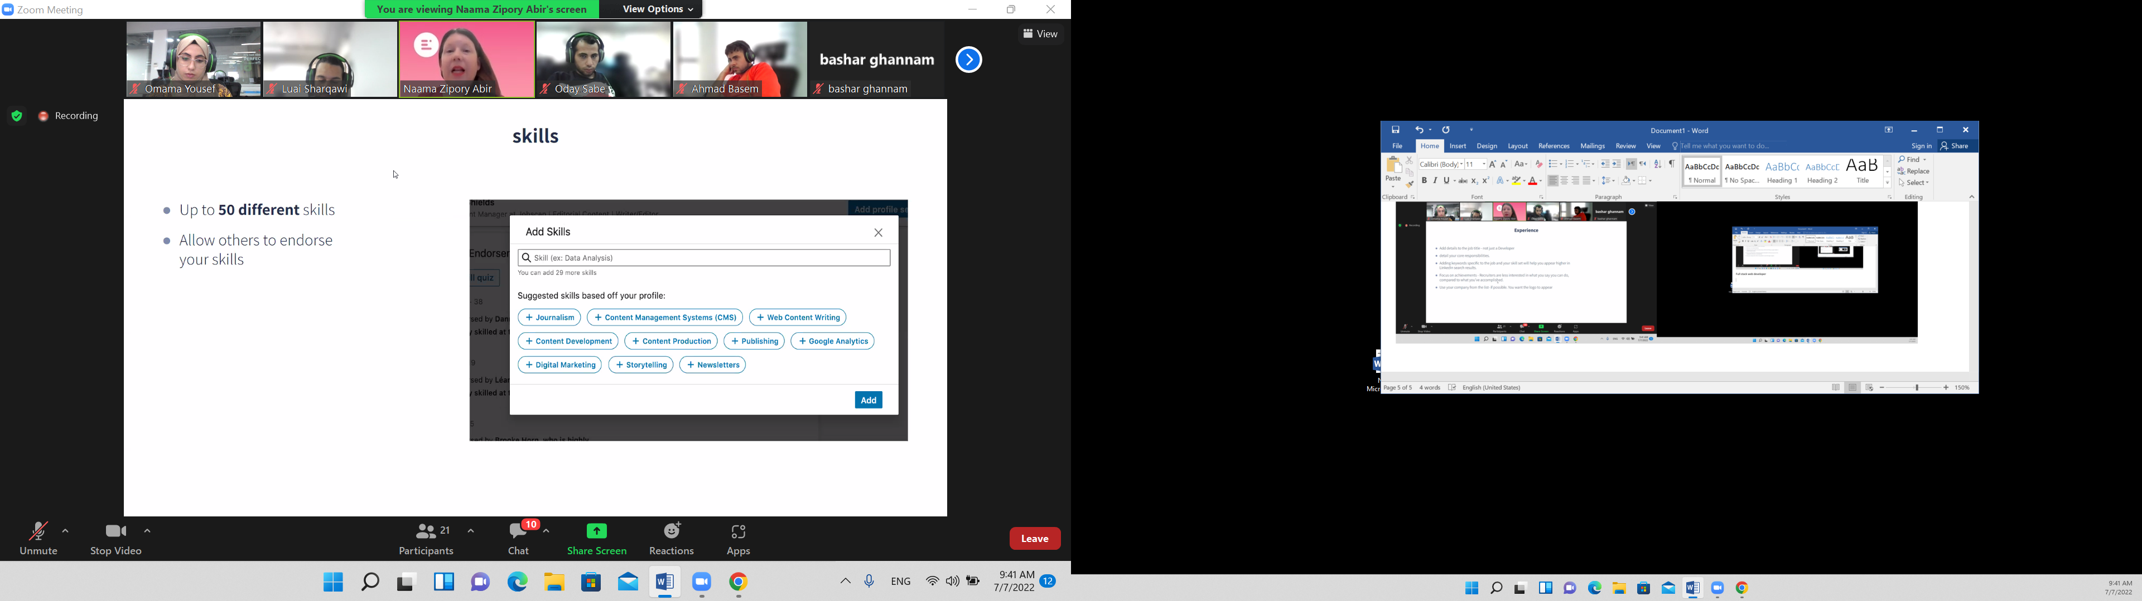

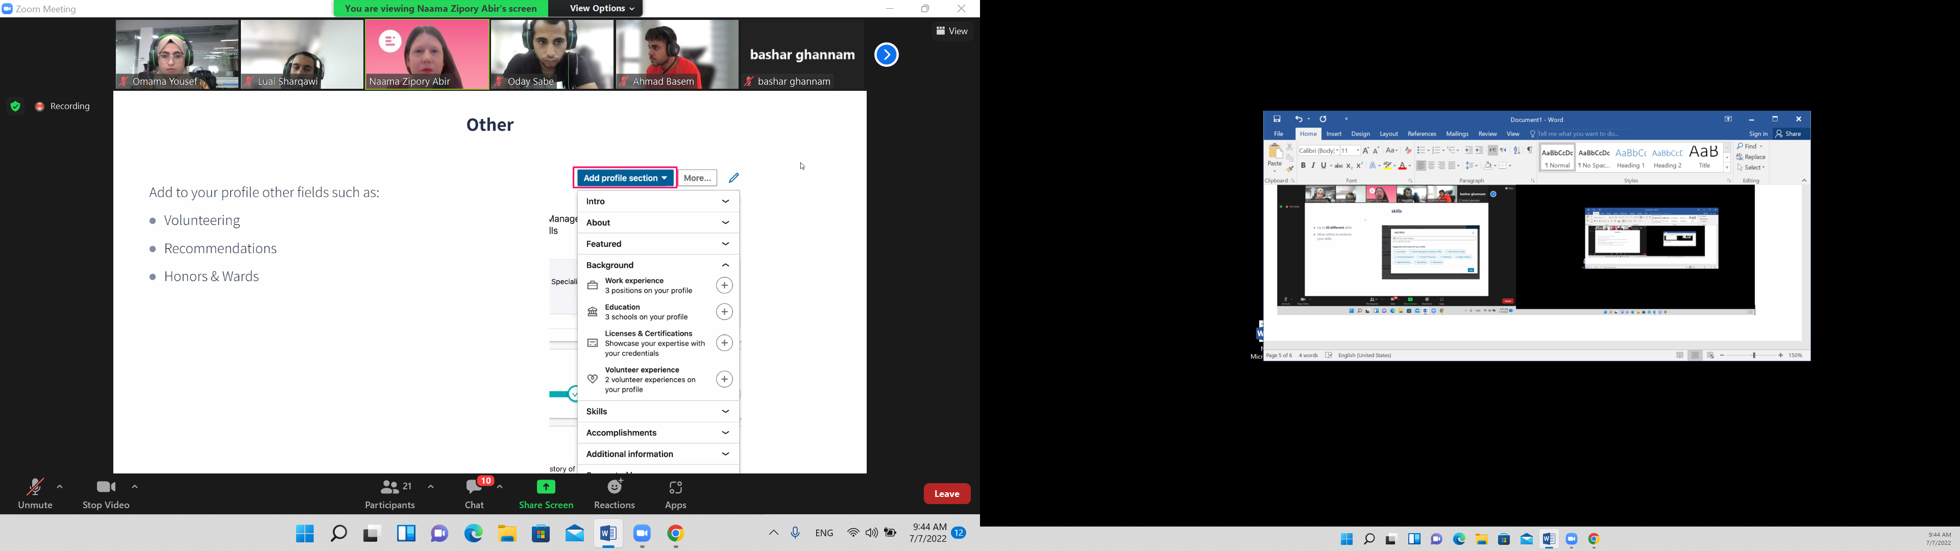

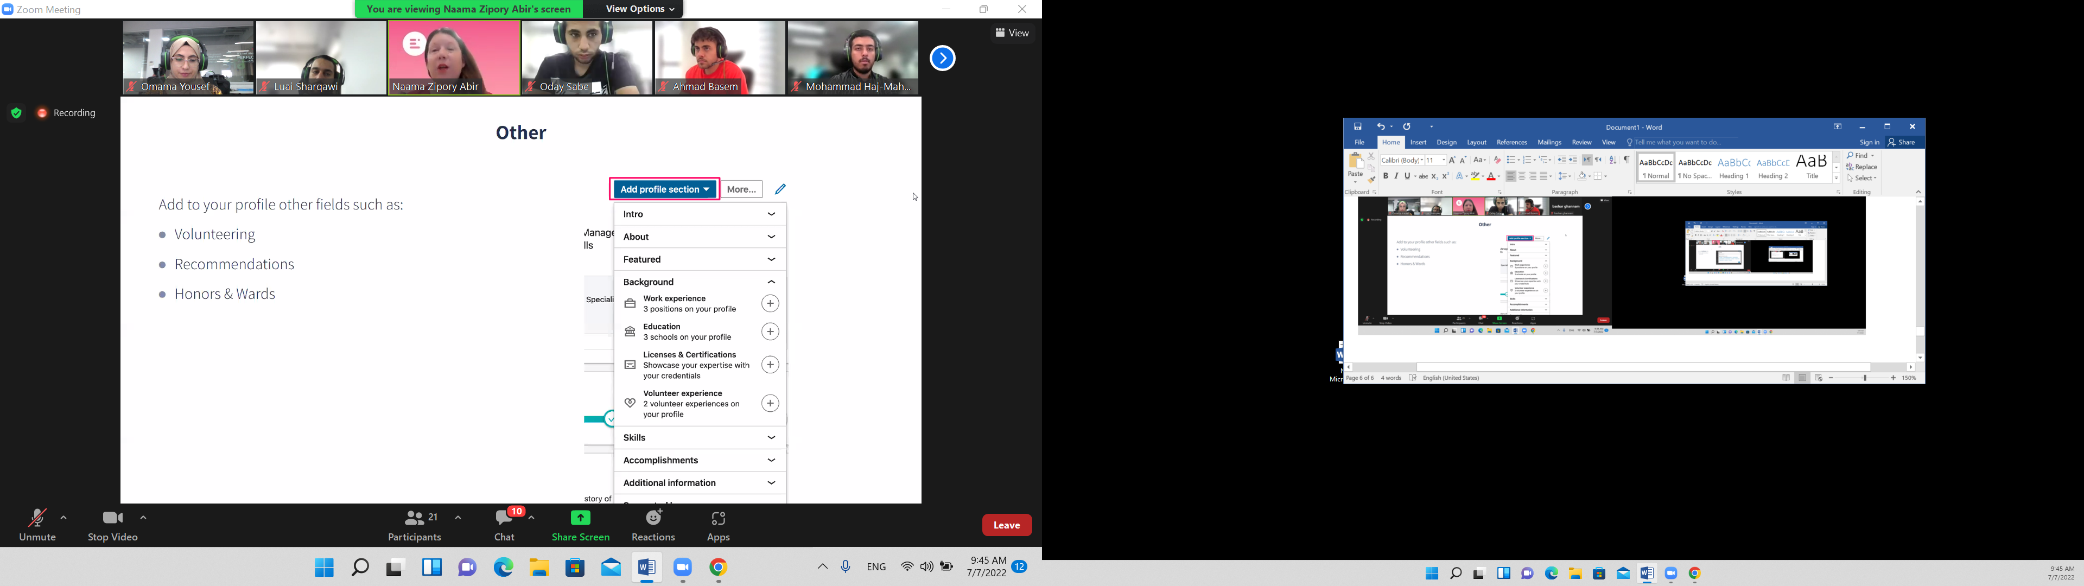

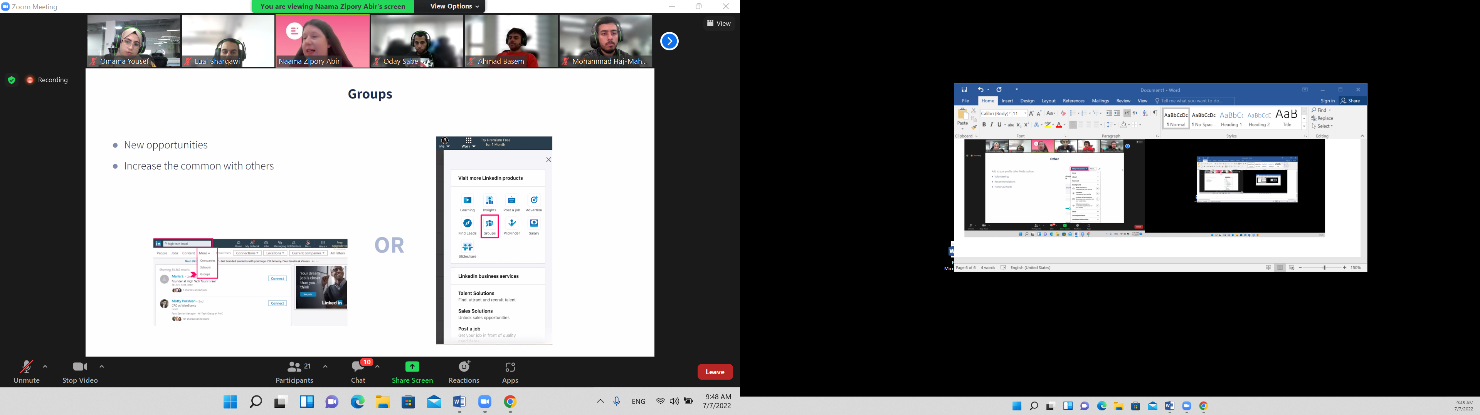

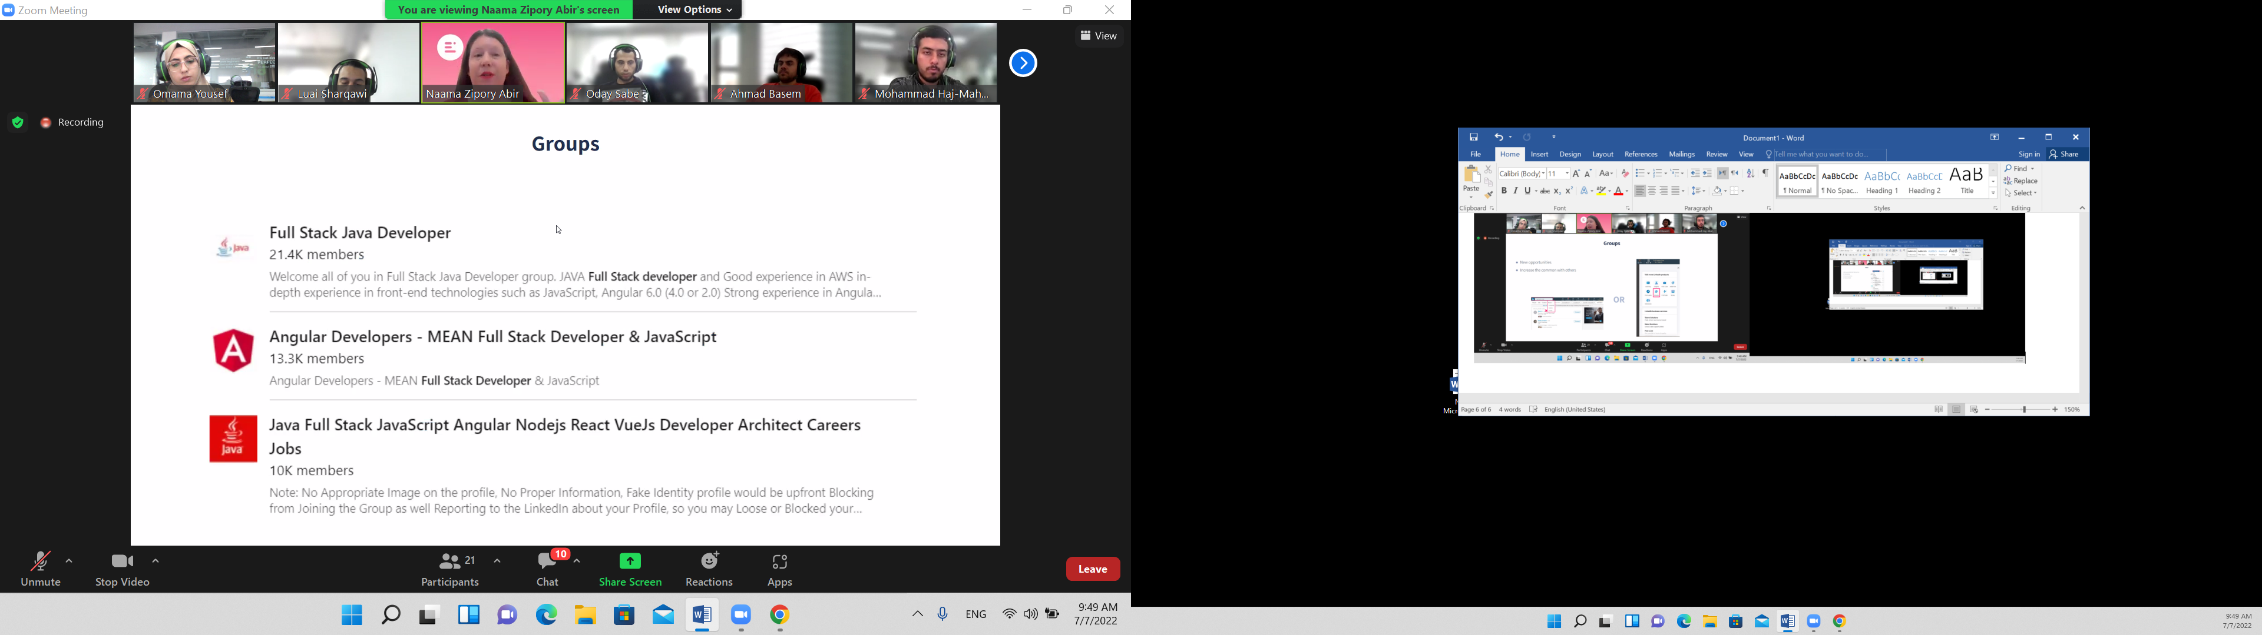

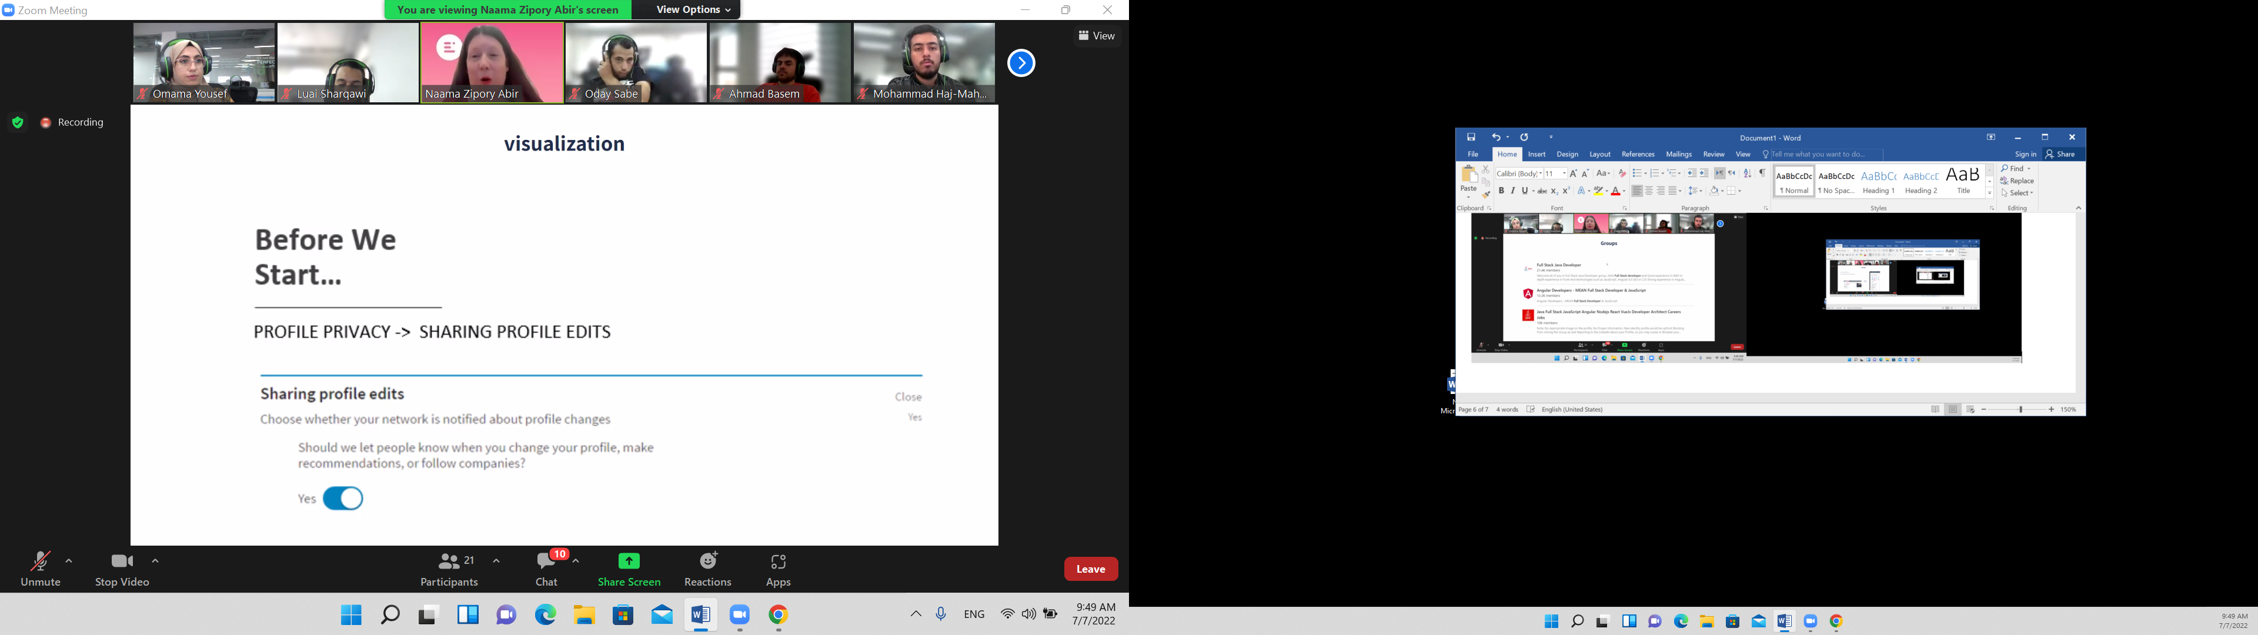

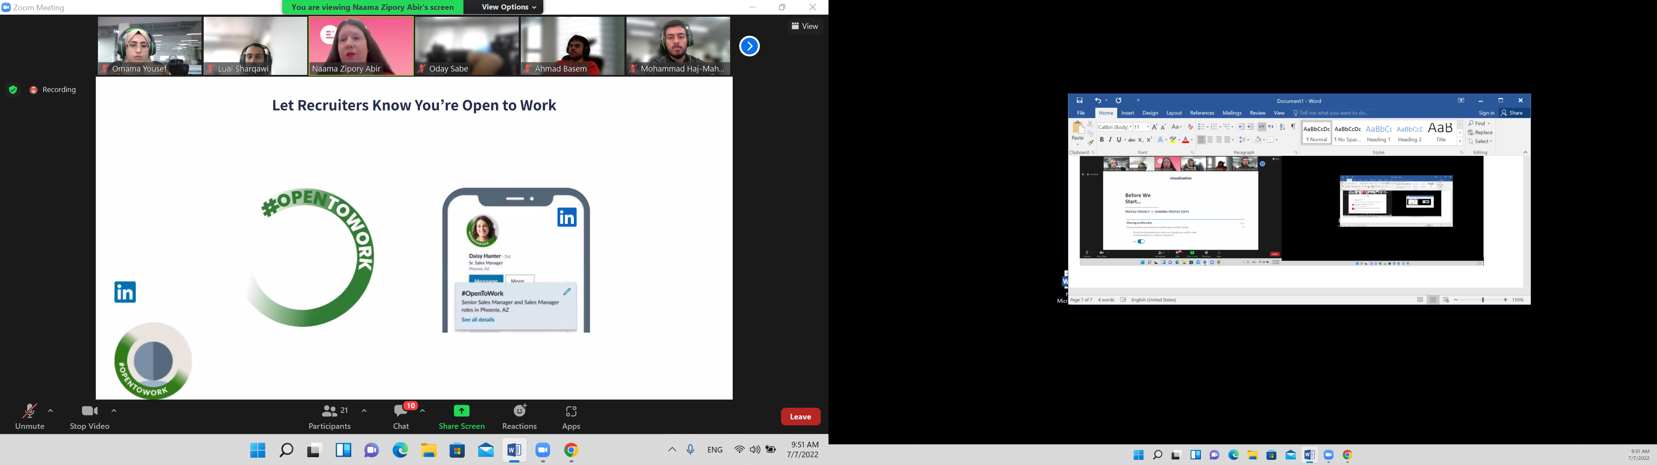

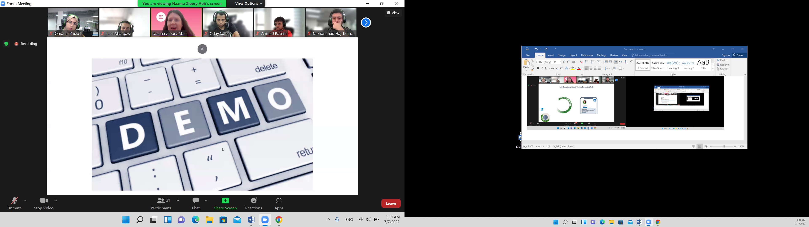

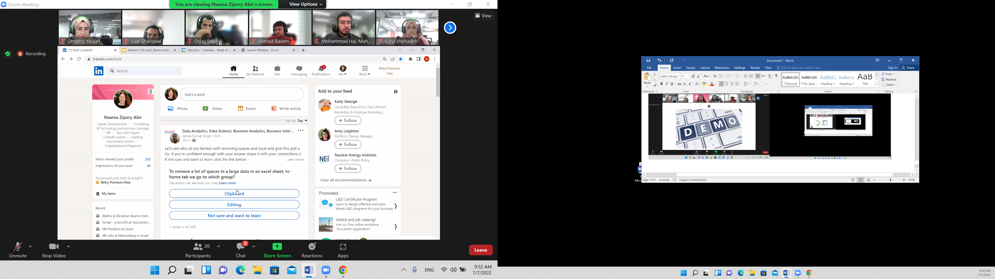

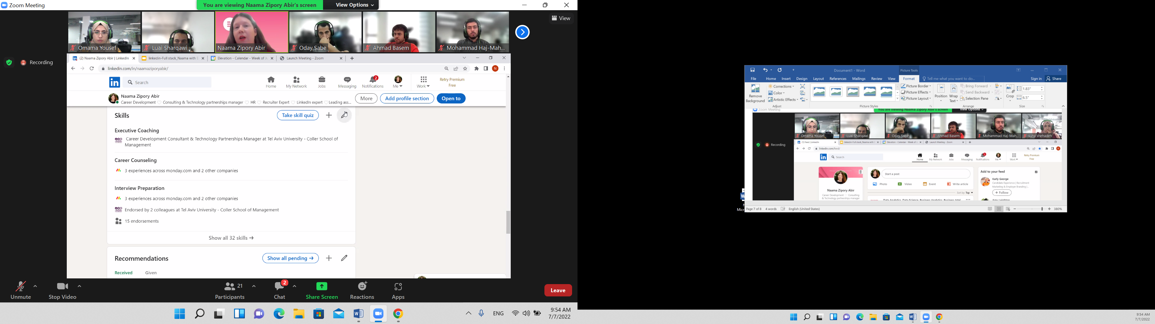

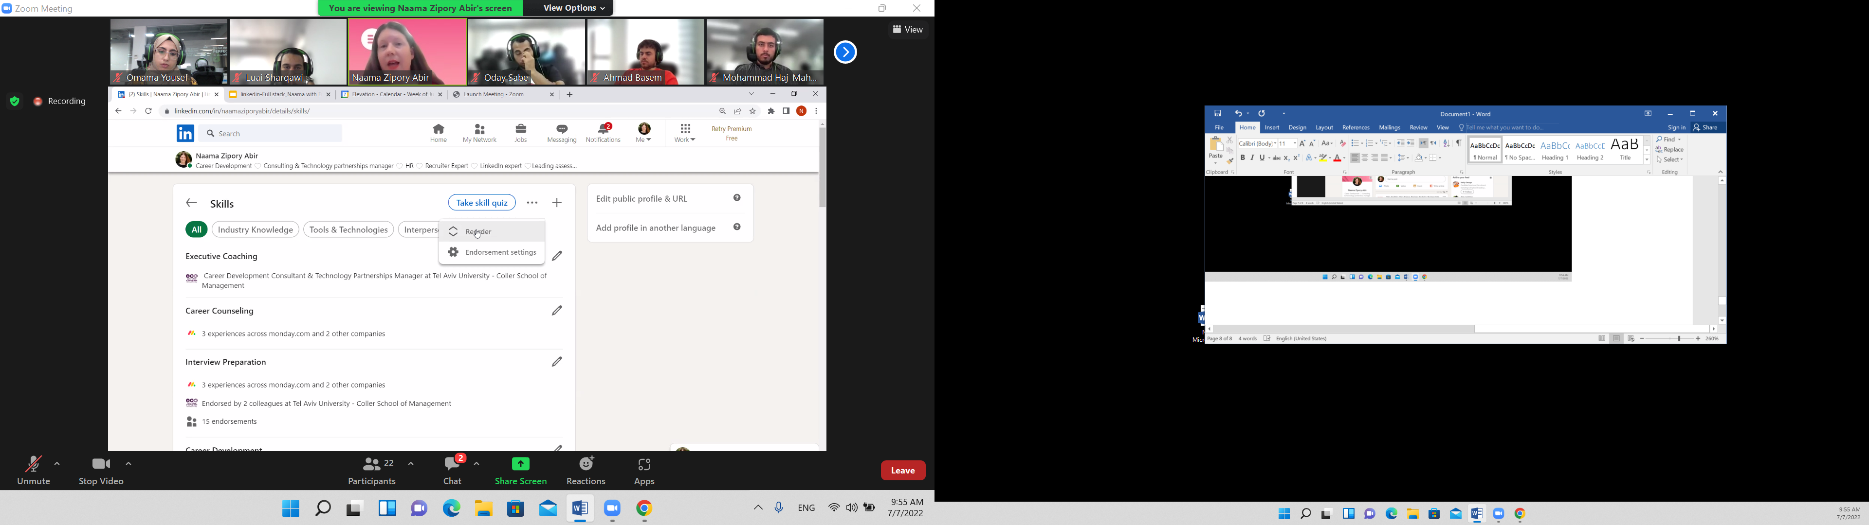

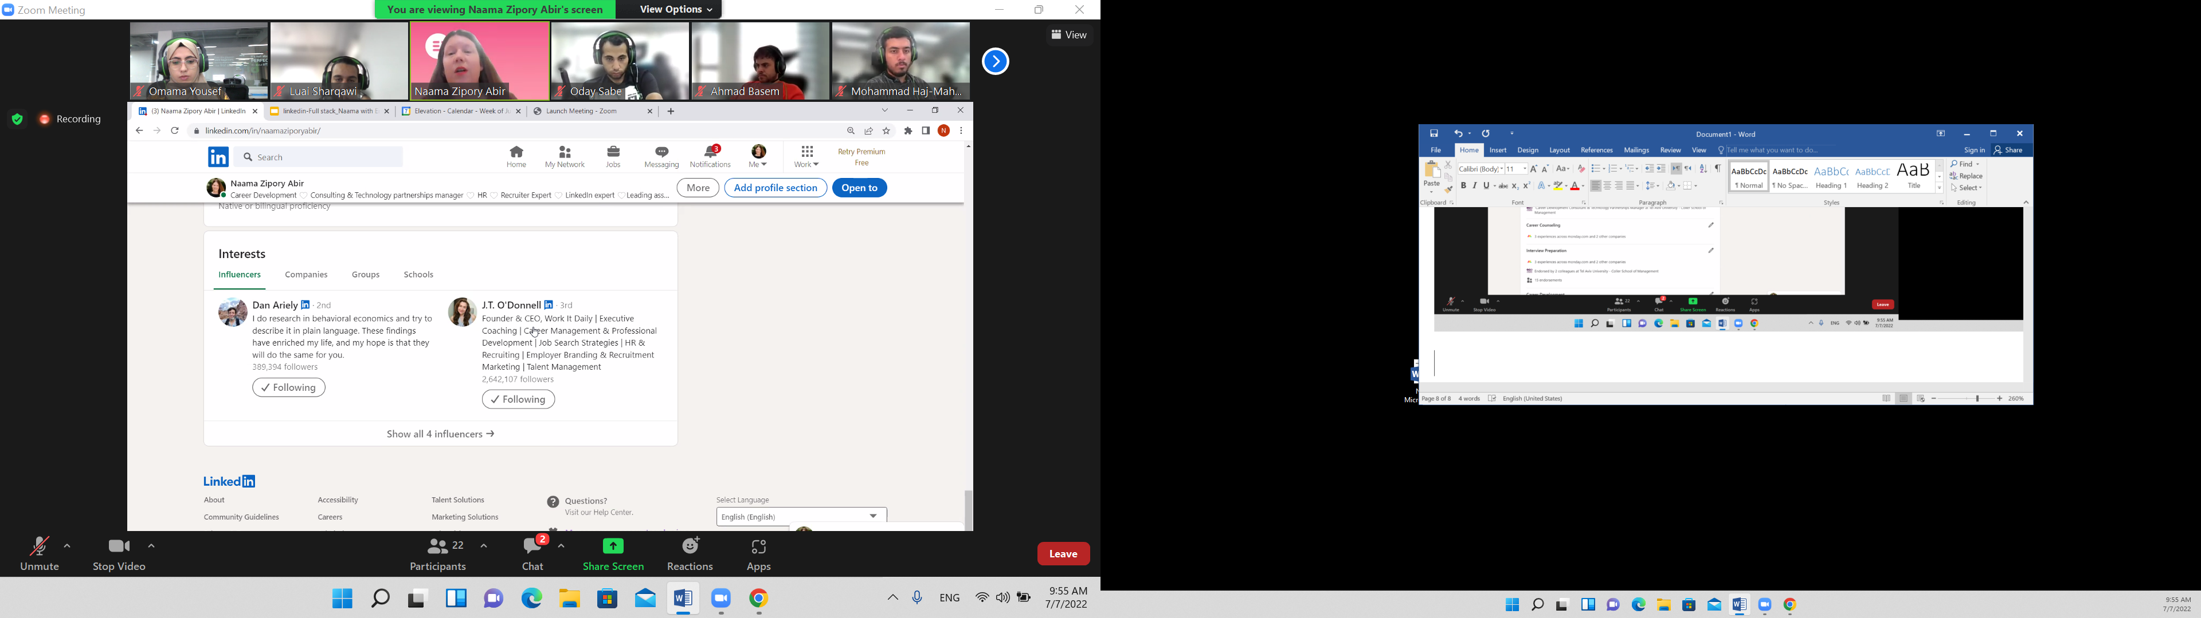

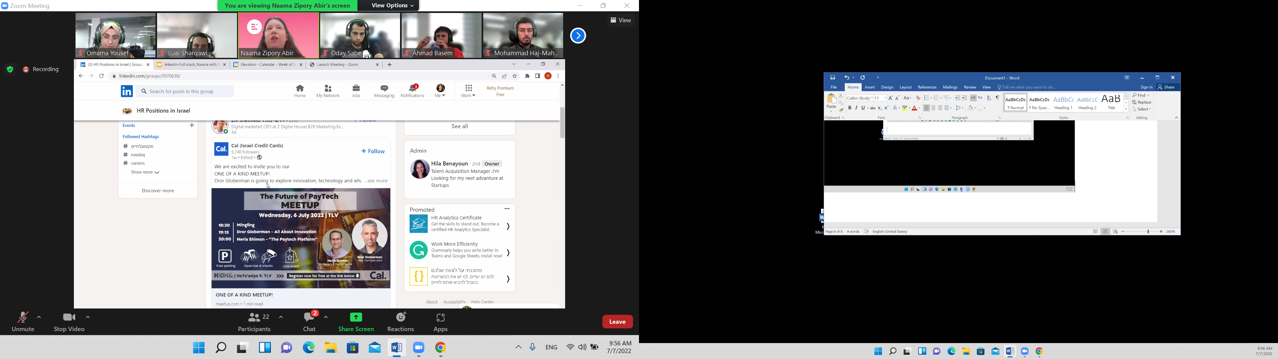

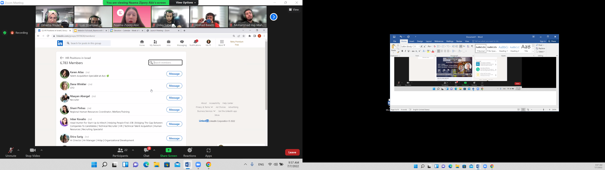

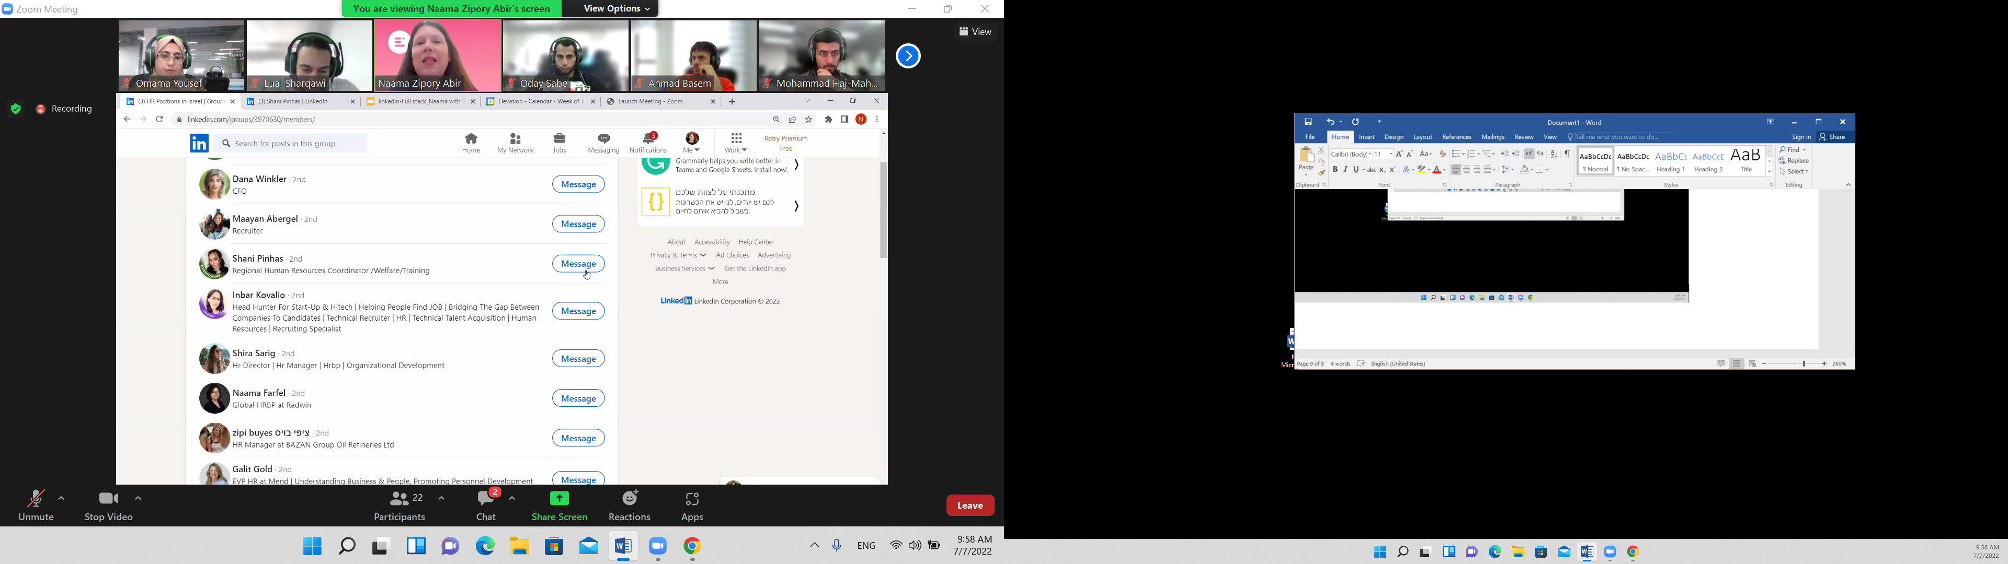

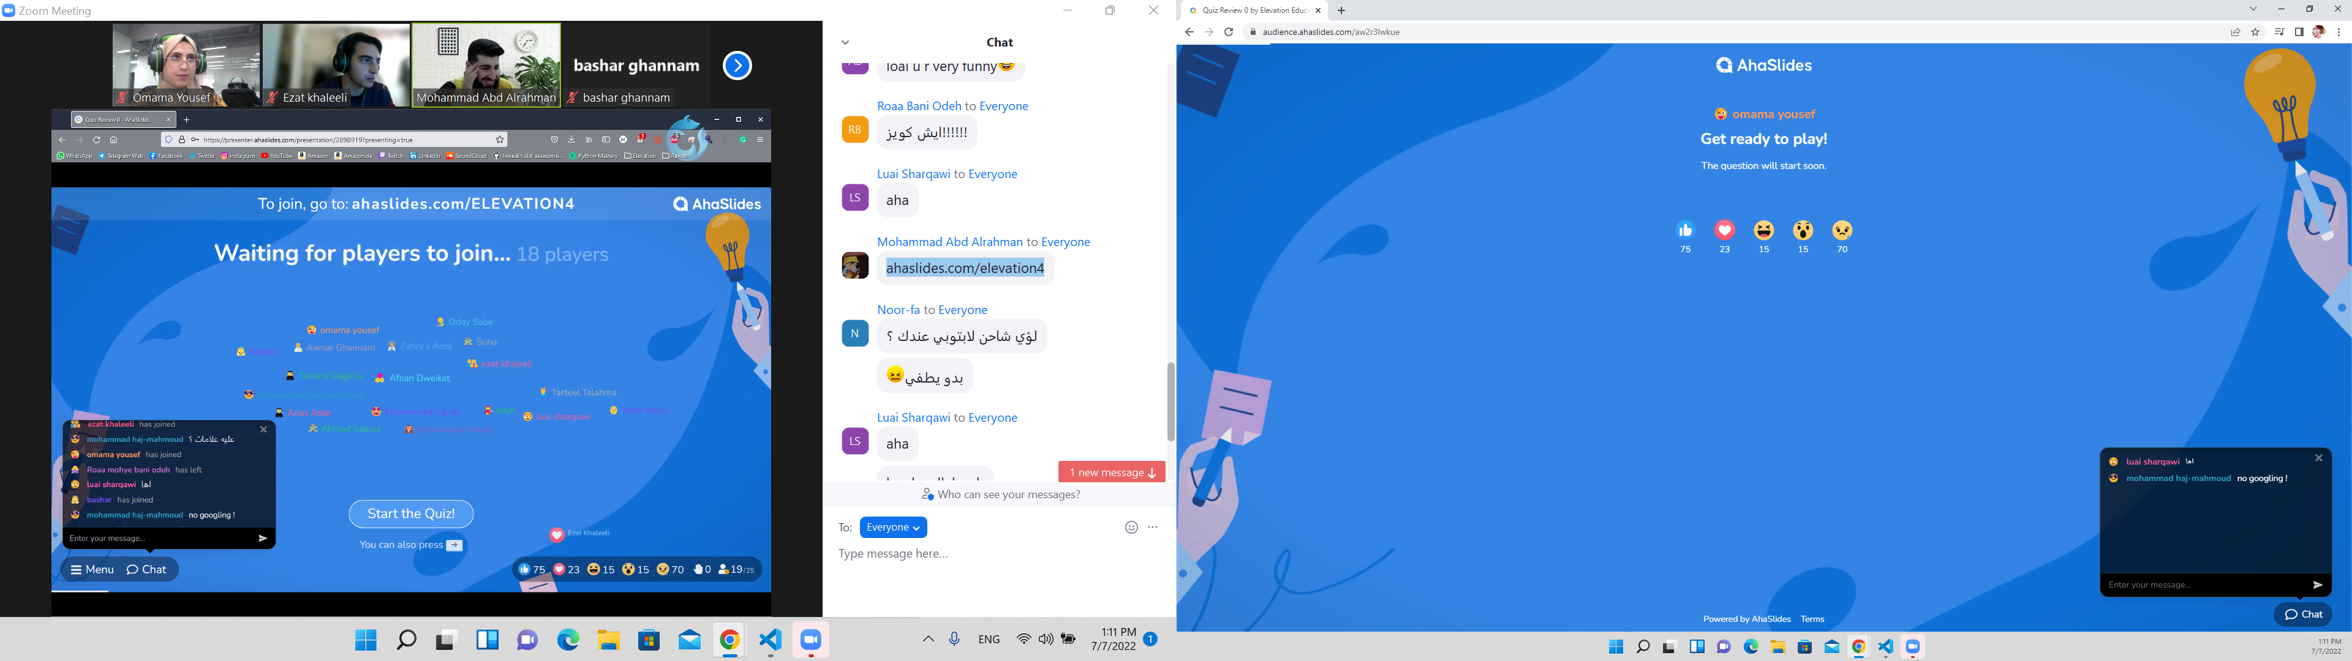

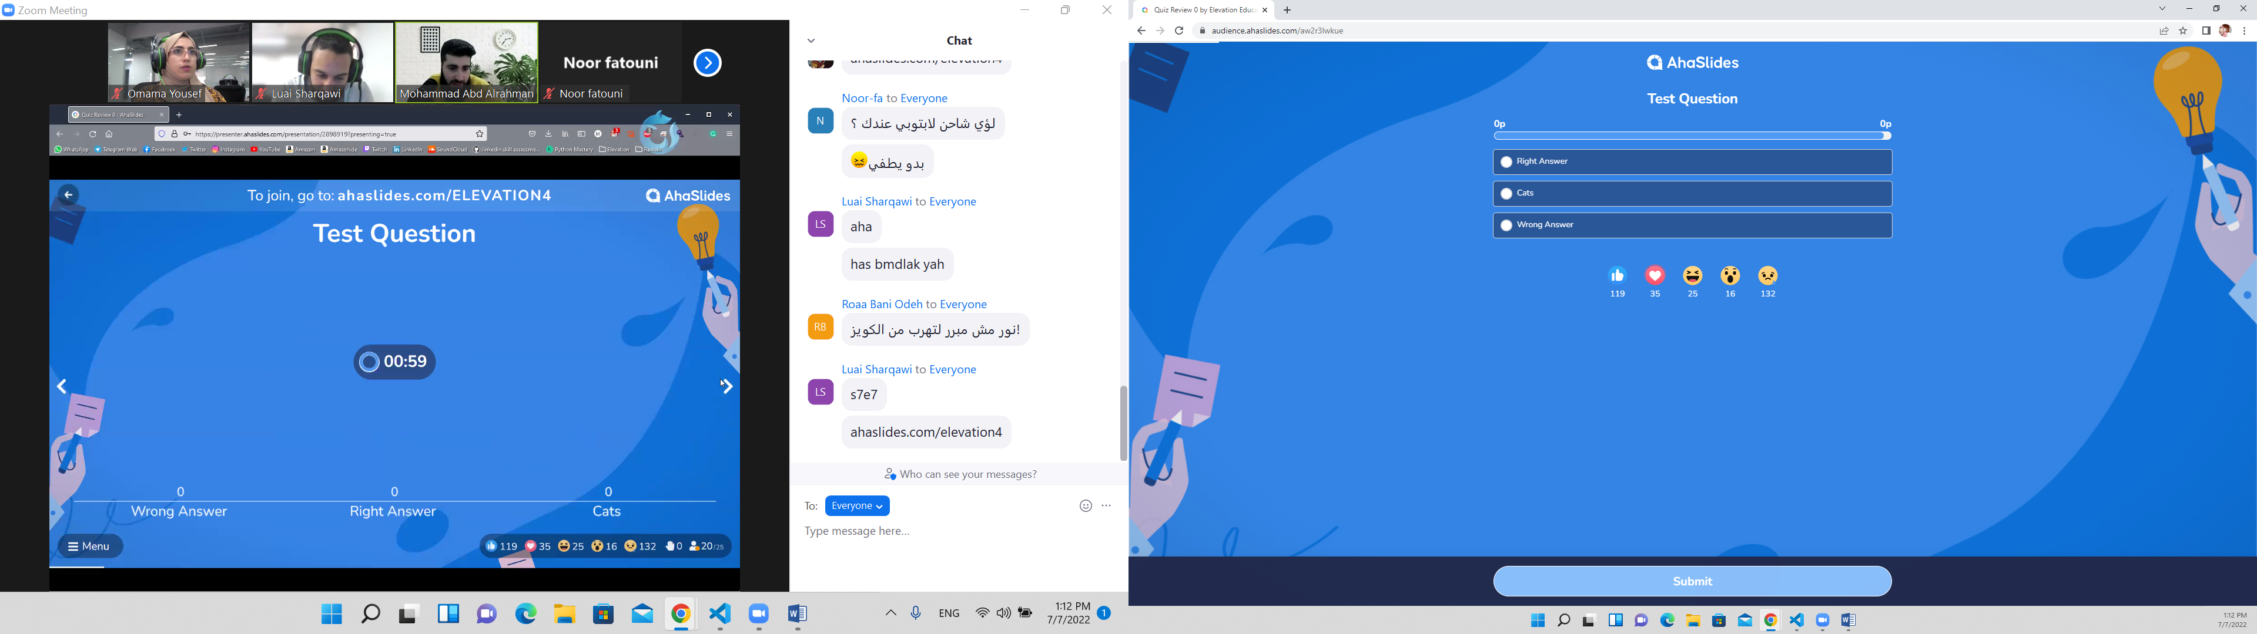

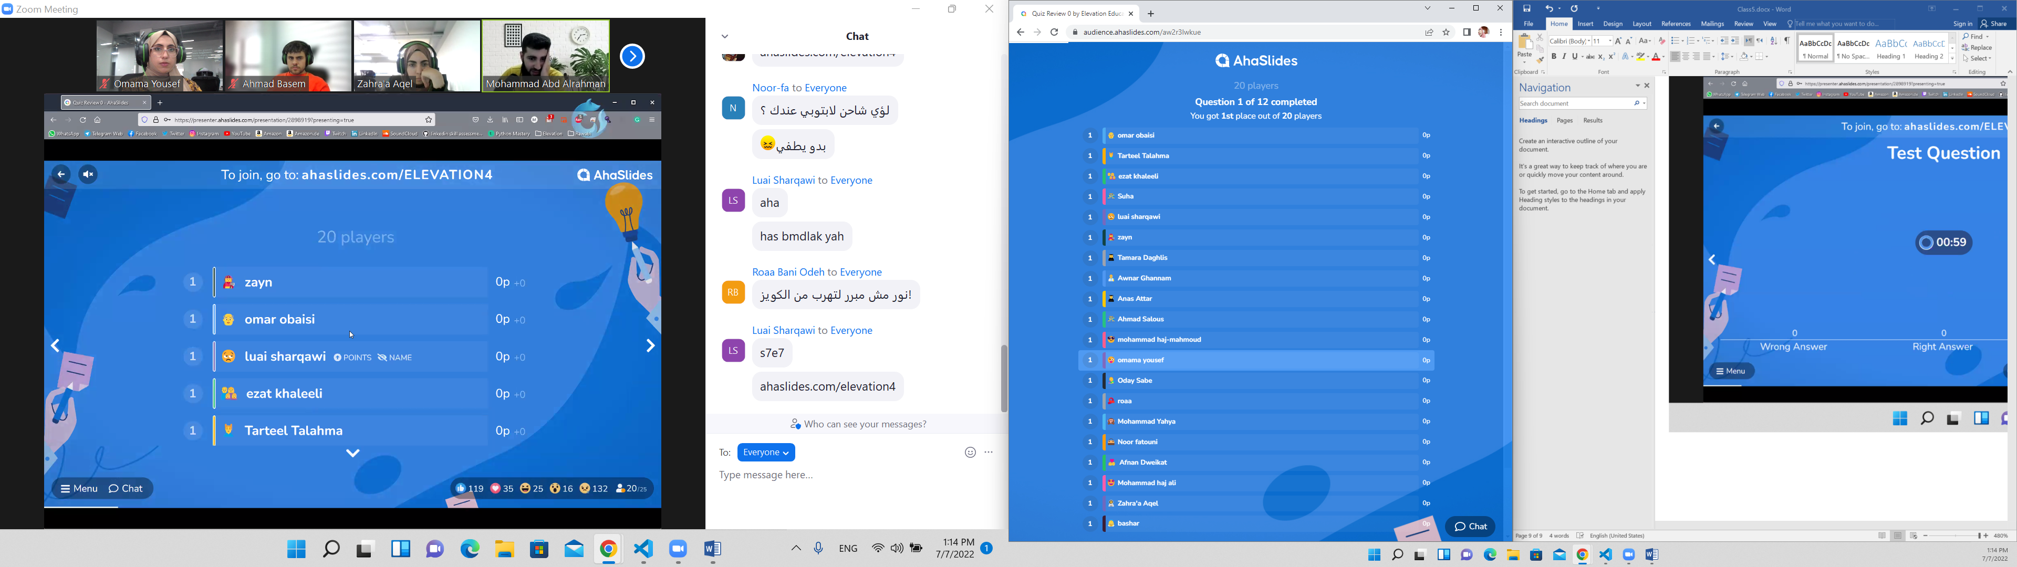

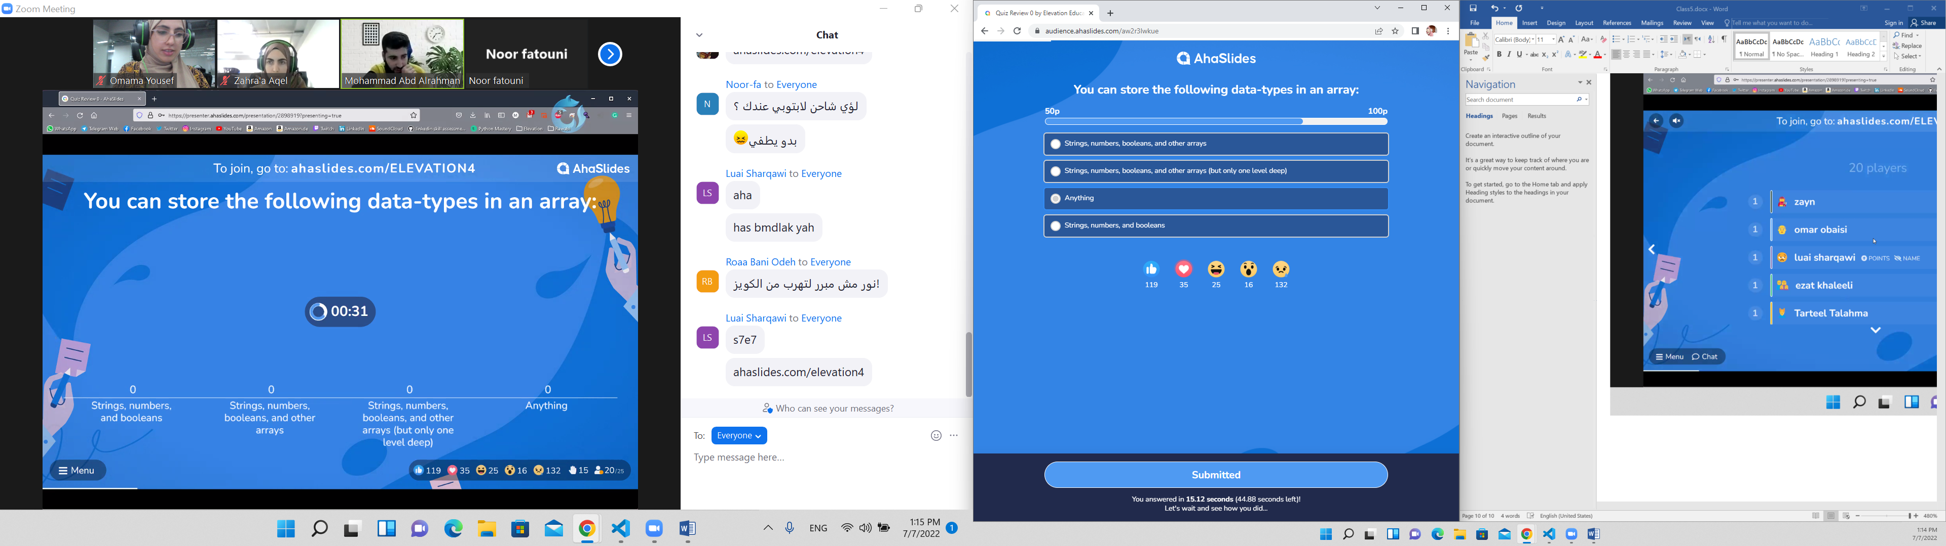

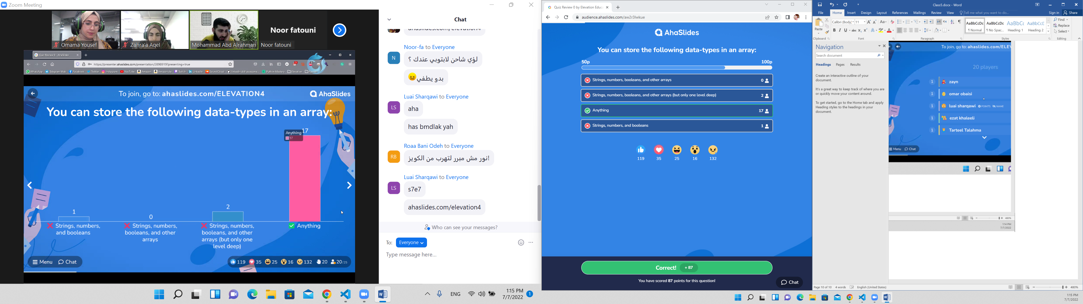

A

